Exercise 6

**Problem Statement:**

Mr. Arun Student of Presidency University wants to create an attractive web page for Presidency University using HTML and CSS with following specifications.

* Split the web page into two parts using frames, top section 20% and bottom section 80%.
* Place your college logo at the top of the page with menu’s (About, Academic, Admission, Facilities, etc). Create hyperlink for all menus.
* Create a web page about the college linked at the bottom of the frame.
* Create a web page about the Academic linked at the bottom of the frame.
* Create a web page about the admission, list out the departments, click any deportment name that connects to the registration page and apply the position concept in CSS.
* Create a web page about the Facilities, list out the college facilities and display the images using floating concepts in CSS.
* Create a web page about the login page linked at the bottom of the frame.

**Output:**

Home page:

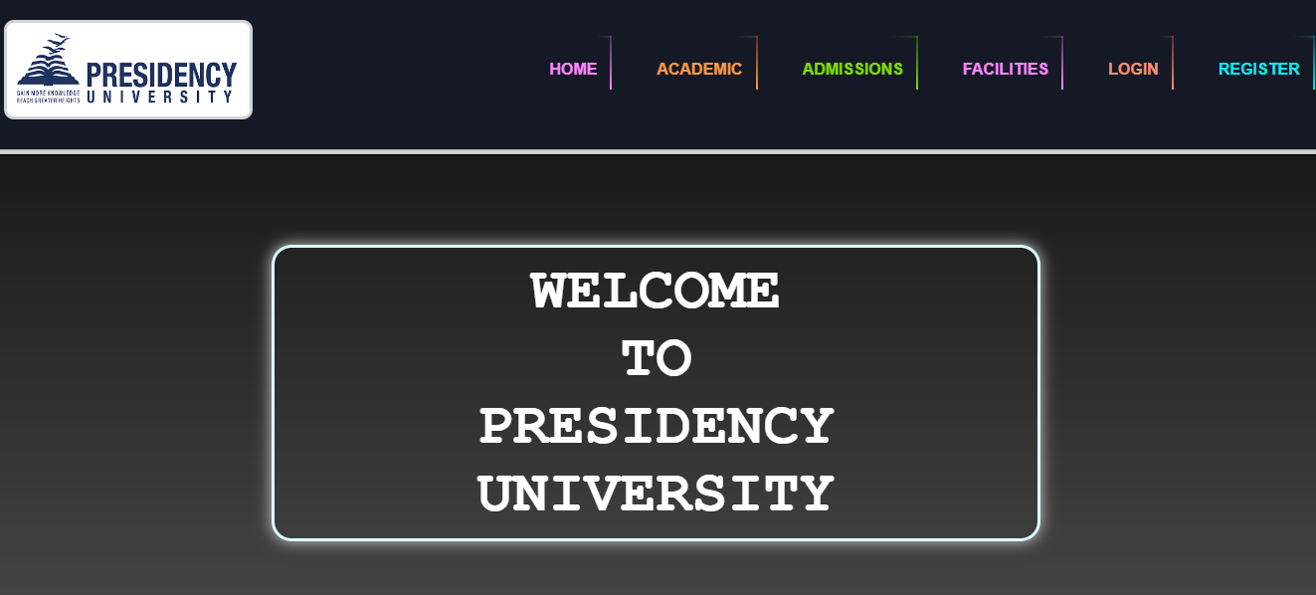

Admission page

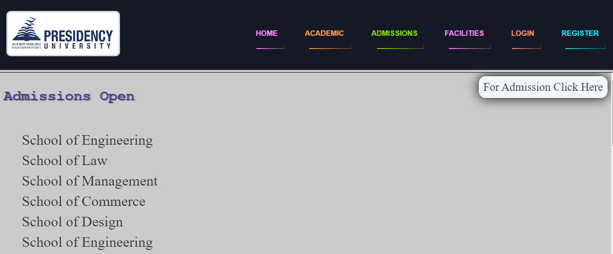

Facilities Page

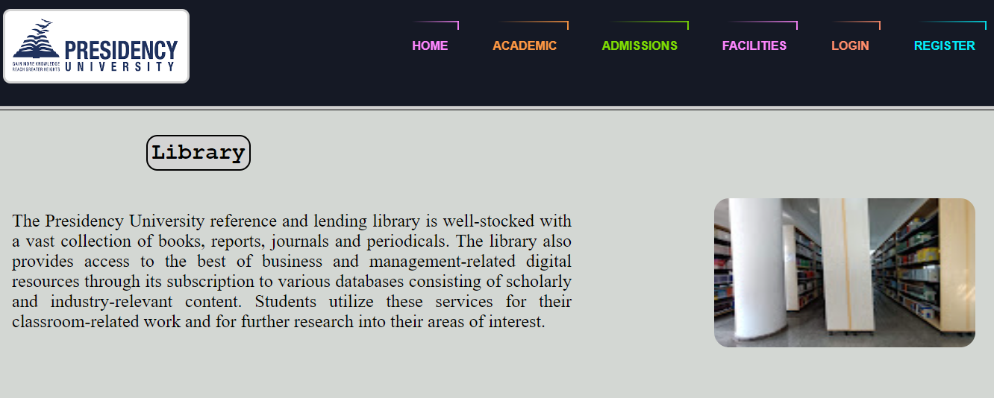

Login page

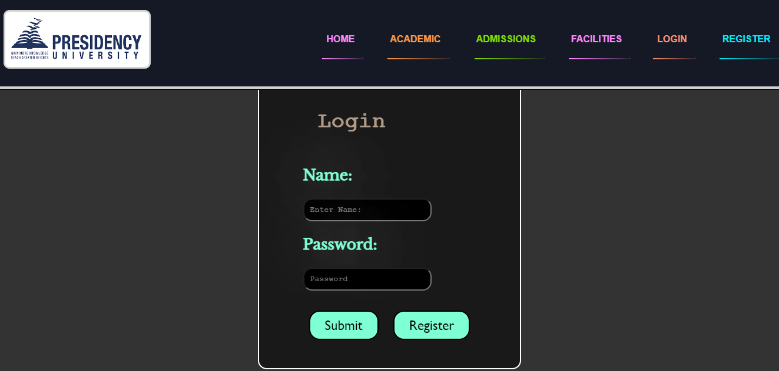

Registration page

